AngularJS Exercise

# Exercise 1:

* Create folder call “AngularJS”
* Copy “lib” folder to “AngularJS” folder
* Using Bracket (or another IDE) open “AngularJS” folder
* Create folder name “Ex1”
* In “Ex1” folder, Create HTML file with name “hello.html”

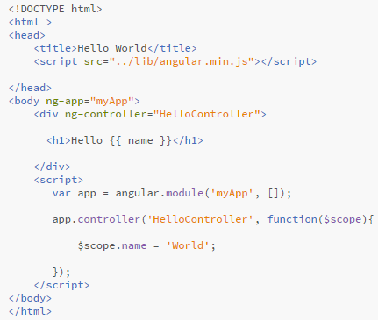

# Exercise 2:

* Open and modify “hello.html” file above

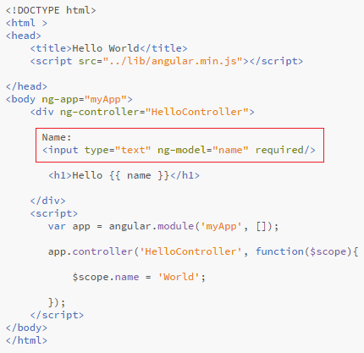

# Exercise 3: scope inheritance

* Create folder name “Ex3”
* In “Ex3” folder, Create HTML file with name “scope-inherit.html”

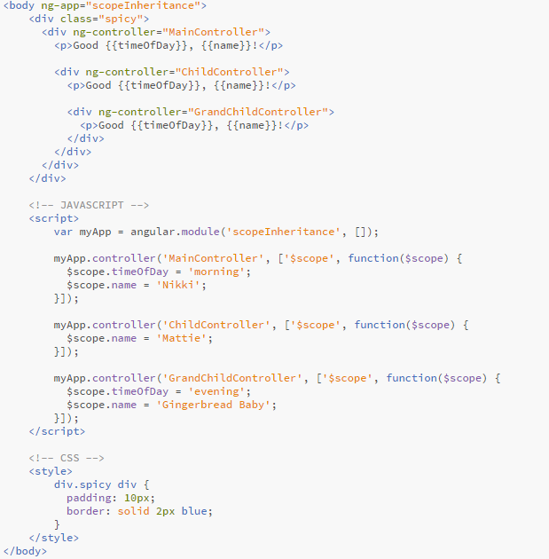

# Exercise 4: scope watch & apply

* Create folder name “Ex4”
* In “Ex4” folder, Create HTML file with name “scope-watch.html”

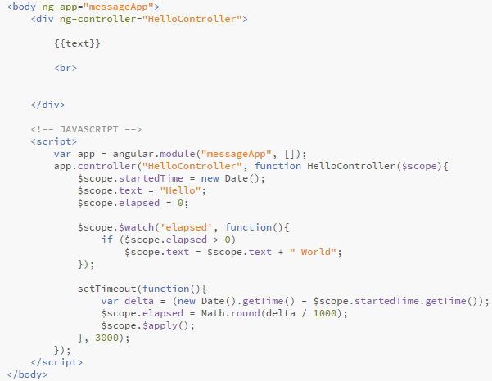

# Exercise 5: scope event

* Create folder name “Ex5”
* In “Ex5” folder, Create HTML file with name “scope-event.html”

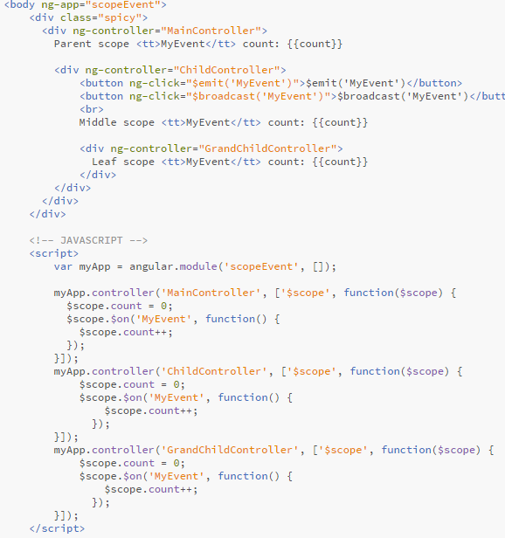

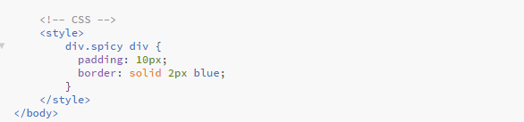

# Exercise 6: Form Validation

* Create folder name “Ex6”
* In “Ex6” folder, Create HTML file with name “form.html”

